Stockphoto.js java script plugin revision

The basic problem we are trying to solve is to speed up the insertion of images and related meta data from commons.wikimedia.org into the Artkick database. We would like to build on the Stockphoto browser addition which allows a user to click a button and download images from the website. We want to modify the code to instead of downloading an image, it inserts a record into the artkick database

[Stockphoto.js](http://commons.wikimedia.org/wiki/MediaWiki:Gadget-Stockphoto.js) is a browser addition which adds download buttons to image pages at commons.wikimedia.org. You must be logged into Wikimedia commons for this to show up. A description of the addition is [here](http://commons.wikimedia.org/wiki/Help:Gadget-Stockphoto).

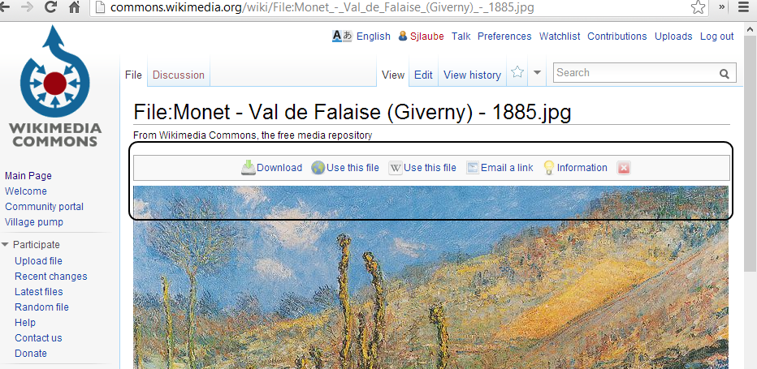\

When a user clicks the “download” button they get the following dialog:

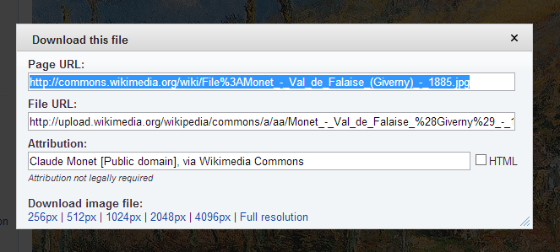

This document describes how we would like to modify the actions of photostock.js to perform new related functions.

Overview

We would like use the photostock.js module to directly upload metadata from the image page directly into a database, rather than download an image. The user will be able to review the meta data extracted from the HTML page and edit it before the information is stored in a database. We would like to add a button to the photostock.js tool bar “upload to artkick”. When the user clicks the button the following proposed UI is displayed with the extracted metadata:

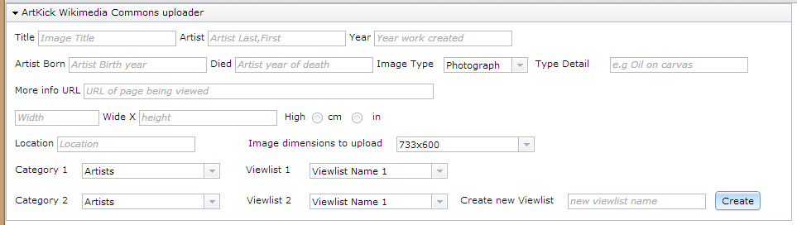

Field Definitions: (using [this file](http://commons.wikimedia.org/wiki/File:Monet_-_Val_de_Falaise_(Giverny)_-_1885.jpg) as example)

Title: id= fileinfopl_art_title then class=description en, then inner html

Artist: extracted from id=”creator” then title=”artist name”

Year: id=”fileinfopl_date”, then datetime=”year”

Artist Born: id=fileinfotpl_creator_birthdate_value, then datetime=”birthday”

Artist Died: id=fileinfotpl_creator_deathdate_value, then datetime=”deathdate”

Type: Input by user

Type Detail: id=fileinfopl_art_medium, then inner html

More info URL: URL of current page

Dimensions: id=fileinfopl_art_dimensions then inner html

Location: id=fileinfopl_art_location then inner html

Image dimensions to upload: id=mw-content-text then scan each href in the <div>. Each href is followed by class=”mw-thumbnail-link” followed by dimension of the thumbnail in pixels. Create entry in the pull down control for each different set of dimensions. What is actually uploaded is the URL of the image at the selected resolution, not the image itself.

Categories: list is obtained by an api call to server which will return a json of the possible categories. See figure 1 for a description of this call

Viewlist 1 & 2: list is obtained by an api call to server which returns a json of possible viewlists for the related selected category (the hierarchy is categories -> viewlists -> images. See figure 2 for a description of this call

Create new viewlist: user can enter a new viewlist name. when they click the “create” button, call an api with the new name. you then have to refresh the viewlist 1&2 depending on the category which is selected. Api not yet defined will be done in next few days

Upload to Artkick Button: when this button is pressed an api call is made with a json to insert the record into the database. Api not yet defined will be done in next few days.

Figure 1:

Call url: <http://evening-garden-3648.herokuapp.com/content/allCategories>

Returns list of all categories in following format:

{"categories":[{"_id":{"$oid":"51ed8ad31fc9fb0498000004"},"date":"2013-07-22 12:41:07 -0700","name":"Home Décor","tags":[],"user_email":"sheldon@zwamy.com","user_name":"Sheldon-zwamy","viewlists":[]},{"_id":{"$oid":"51ed8b251fc9fb0498000009"},"name":"Sports","user_name":"Sheldon-zwamy","user_email":"sheldon@zwamy.com","date":"2013-07-22 12:42:29 -0700","tags":[],"viewlists":[]},{"_id":{"$oid":"51ed8a911fc9fb0498000002"},"date":"2013-07-22 12:40:01 -0700","name":"Children's Art","tags":[],"user_email":"sheldon@zwamy.com","user_name":"Sheldon-zwamy","viewlists":[]},{"_id":{"$oid":"51ed8ab31fc9fb0498000003"},"date":"2013-07-22 12:40:35 -0700","name":"Fine Art","tags":[],"user_email":"sheldon@zwamy.com","user_name":"Sheldon-zwamy","viewlists":[143]},{"_id":{"$oid":"51ed8b341fc9fb049800000a"},"date":"2013-07-22 12:42:44 -0700","name":"Top Lists","tags":[],"user_email":"sheldon@zwamy.com","user_name":"Sheldon-zwamy","viewlists":[126]},{"_id":{"$oid":"51ed8af21fc9fb0498000005"},"date":"2013-07-22 12:41:38 -0700","name":"Landscapes","tags":[],"user_email":"sheldon@zwamy.com","user_name":"Sheldon-zwamy","viewlists":[]},{"_id":{"$oid":"51ed8b151fc9fb0498000008"},"date":"2013-07-22 12:42:13 -0700","name":"Space Exploration","tags":[],"user_email":"sheldon@zwamy.com","user_name":"Sheldon-zwamy","viewlists":[128,130]},{"_id":{"$oid":"51ed8b051fc9fb0498000007"},"date":"2013-07-22 12:41:57 -0700","name":"Photography","tags":[],"user_email":"sheldon@zwamy.com","user_name":"Sheldon-zwamy","viewlists":[127,129,131,132,133,134,135,136,137,138,139,140,141,142]},{"_id":{"$oid":"51ed8afb1fc9fb0498000006"},"date":"2013-07-22 12:41:47 -0700","name":"Museums","tags":[],"user_email":"sheldon@zwamy.com","user_name":"Sheldon-zwamy","viewlists":[144,145,146,147,148,149,150,151,152,153,154]}]}

Foreach category the api returns

Internal id

Date category was created

Category name

Tags associated with category

Email of user who created category

Artkick user name of user who created category

List of viewlist id’s which are members of this category.

Figure 2:

Call URL: <http://evening-garden-3648.herokuapp.com/content/getViewlistsByCategory?catName=Photography>

Which returns:

{"status":"success","viewlists":[{"_id":{"$oid":"51f018641c2e5720bd111afe"},"categories":["Photography"],"coverImage":"http://s3.amazonaws.com/zwamy/thumbnails/th793.jpg","creator":1,"datetime_created":"2013-07-24 18:09:40","id":127,"images":[793,794,795,796,797,798,799,800,801,802,803,804,822,823,824,825,826,827,828,829,830,831,832,833,834,835,836,837,838,839,840,841,842,843,844,845,846,847,848,849,850,851,852,853,854,855,861,862,863,864,865,866,867,868,869,870,871,872,873,874,875,876,877,878,879,880,881,882,883,884,885,886,887,888,889,890,891,892,893,894],"name":"Space","tags":[]},{"_id":{"$oid":"51f018a71c2e5720bd111b0c"},"categories":["Photography"],"coverImage":"http://s3.amazonaws.com/zwamy/thumbnails/th805.jpg","creator":1,"datetime_created":"2013-07-24 18:10:47","id":129,"images":[805,806,807,808,809,810,811,812,813,814,815,816,817,818,819,820,821],"name":"Historical","tags":[]},{"_id":{"$oid":"51f019bd1c2e5720bd111b41"},"categories":["Photography"],"coverImage":"http://s3.amazonaws.com/zwamy/thumbnails/th856.jpg","creator":1,"datetime_created":"2013-07-24 18:15:25","id":131,"images":[856,860],"name":"People","tags":[]},{"_id":{"$oid":"51f019c31c2e5720bd111b43"},"categories":["Photography"],"coverImage":"http://s3.amazonaws.com/zwamy/thumbnails/th857.jpg","creator":1,"datetime_created":"2013-07-24 18:15:31","id":132,"images":[857,858,859],"name":"Vehicles","tags":[]},{"_id":{"$oid":"51f01b1a1c2e57211cb2a921"},"categories":["Photography"],"coverImage":"http://s3.amazonaws.com/zwamy/thumbnails/th895.jpg","creator":1,"datetime_created":"2013-07-24 18:21:14","id":133,"images":[895,900,901,921,930,933],"name":"Buildings","tags":[]},{"_id":{"$oid":"51f01b1d1c2e57211cb2a923"},"categories":["Photography"],"coverImage":"http://s3.amazonaws.com/zwamy/thumbnails/th896.jpg","creator":1,"datetime_created":"2013-07-24 18:21:17","id":134,"images":[896,924],"name":"Food","tags":[]},{"_id":{"$oid":"51f01b1f1c2e57211cb2a925"},"categories":["Photography"],"coverImage":"http://s3.amazonaws.com/zwamy/thumbnails/th897.jpg","creator":1,"datetime_created":"2013-07-24 18:21:19","id":135,"images":[897,898,899,903,909,910,913,914,915,916,917,918,926,931],"name":"Vehicles","tags":[]},{"_id":{"$oid":"51f01b2d1c2e57211cb2a92b"},"categories":["Photography"],"coverImage":"http://s3.amazonaws.com/zwamy/thumbnails/th902.jpg","creator":1,"datetime_created":"2013-07-24 18:21:33","id":136,"images":[902,904,906,908,923,932],"name":"Landmarks","tags":[]},{"_id":{"$oid":"51f01b381c2e57211cb2a92f"},"categories":["Photography"],"coverImage":"http://s3.amazonaws.com/zwamy/thumbnails/th905.jpg","creator":1,"datetime_created":"2013-07-24 18:21:44","id":137,"images":[905,920,922,936],"name":"Dogs","tags":[]},{"_id":{"$oid":"51f01b3f1c2e57211cb2a932"},"categories":["Photography"],"coverImage":"http://s3.amazonaws.com/zwamy/thumbnails/th907.jpg","creator":1,"datetime_created":"2013-07-24 18:21:51","id":138,"images":[907,927,934],"name":"People","tags":[]},{"_id":{"$oid":"51f01b4a1c2e57211cb2a937"},"categories":["Photography"],"coverImage":"http://s3.amazonaws.com/zwamy/thumbnails/th911.jpg","creator":1,"datetime_created":"2013-07-24 18:22:02","id":139,"images":[911,919],"name":"Music","tags":[]},{"_id":{"$oid":"51f01b501c2e57211cb2a939"},"categories":["Photography"],"coverImage":"http://s3.amazonaws.com/zwamy/thumbnails/th912.jpg","creator":1,"datetime_created":"2013-07-24 18:22:08","id":140,"images":[912,925,928],"name":"Horses","tags":[]},{"_id":{"$oid":"51f01b881c2e57211cb2a94b"},"categories":["Photography"],"coverImage":"http://s3.amazonaws.com/zwamy/thumbnails/th929.jpg","creator":1,"datetime_created":"2013-07-24 18:23:04","id":141,"images":[929],"name":"Landscapes","tags":[]},{"_id":{"$oid":"51f01b9b1c2e57211cb2a952"},"categories":["Photography"],"coverImage":"http://s3.amazonaws.com/zwamy/thumbnails/th935.jpg","creator":1,"datetime_created":"2013-07-24 18:23:23","id":142,"images":[935],"name":"Flowers","tags":[]}]}

Foreach viewlist api returns

Category Name

url of thumbnail for the viewlist (not presently used)

date of viewlist creation

list of images in the viewlist

Viewlist Name

List of images in this viewlist